I already explained ===== how to connect chatgpt API

Take some cloud account

Azure account ======

Azure for students ====== no credit card details ==== 100$ free

College email id ====

Azure for non students ==== credit /debit ===== 200$ free ==== deactivate account

How to create azure free account ===== email credit/debit

Azure ML services ==== keys python

By 26th ========

Linear regression ========= OLS

Logistic regression ======= sigmoid

Decision Tree ========== Entropy /gini

Naïve bayes ========= Probability

KNN ========== distance metric

**Classification Metrics**

1. **Confusion matrix**
2. **Accuracy**
3. **Error rate**
4. **Sensitivity**
5. **Specificity**
6. **Precision**
7. **Recall**
8. **F1-score**
9. **Kohens-kappa**
10. **ROC-AUC curve**

$Confusion matrix:$

$Generally in a data , target column has two labels yes and no$

$Model also will predict yes and no$

**Age gender income cr y**

**30 M 50k fair yes**

**You develop the model ====== train data to the model**

**{30,M,50K,fair} ============ yes No**

**How many total combinations**

**Actually yes ,model predicted as No**

**Actually yes, model predicted as yes**

**Actually No , model predicted as No**

**Actually No, model predicted as yes**

$True postive \left(TP\right)=actually yes, model predicted as yes$

$True negative \left(TN\right)=actually no,model predicted as no$

$False postive \left(FP\right)=actually No, model predicted as yes$

$False negative \left(FN\right)=actually yes, model predicted as No$

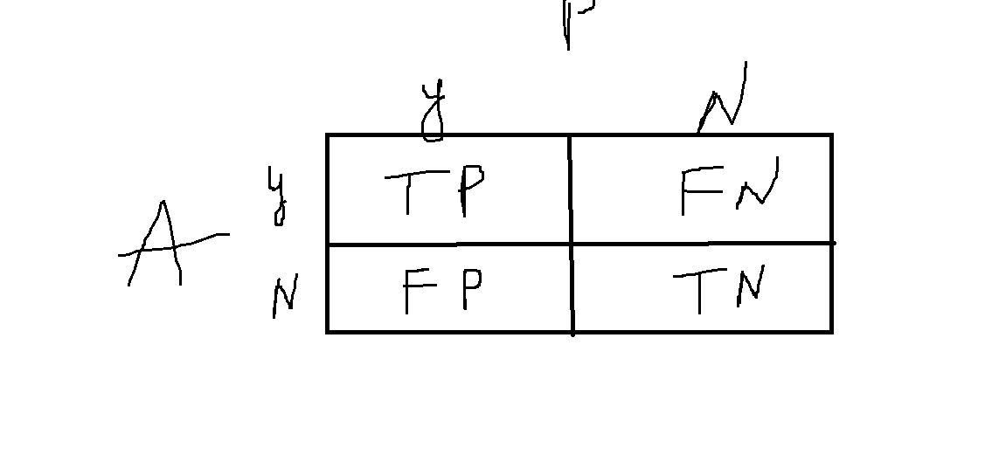

**In a data originally 50 yes are there , 50 No are there**

**Model is predicted 40 yes and 60 No**

**Create the Confusion matrix**

$True postive \left(TP\right)=10$

$True negative \left(TN\right)=20$

$False postive \left(FP\right)=30$

$False negative \left(FN\right)=40$

$Total observations=TP+TN+FP+FN$

$Accuracy: \frac{Tp+Tn}{Total observations}=\frac{Tp+Tn}{Tp+Tn+Fp+Fn}=\frac{10+20}{100}=30\%$

$Error rate:1-0.3=70\%=1-Accuracy$

$Case-1:$

$Avesh khan got a requirement from DMART owner$

$They are requesting him to create a ML model to identify a terrosit$

$He develop the model$

$originally there 100 members are there in that$

$99 members are not a terrorist, 1 person is the terrorist$

$99 NO 1 Yes$

$Model is identify correctly the persons , those who are not a terrorist$

$but model is fail to identify who is actually a terrorist$

$what is the accuracy of model:99, 1,$

$99 NO ======99 NO$

$1 yes========No$

**Tp=0 tn=99 99+0 = 99**

$will feel that model is very good because accuracy is 99\%$

$but it is fail to detect the actual need$

$Accuracy of a model is not prime metric$

$postive analysis and negative analysis$

$True postive rate= out of total postives how many model actually predicting$

$TPR=\frac{TP}{P}$

$only one yes is there P=1$

$TP=0$

$TPR=0\%$

$True negative rate=out of total actual negatives, how model is predicting no$

$TNR=\frac{TN}{N}$

$Number of No=99, model is predicting 99=\frac{99}{99}=100\%$

$TPR=0 TNR=100\% Accuracy=99\%$

$TPR=sensitivity$

$TNR=specificity$

$in above problem there two classe yes and no$

$yes=1 no=99 ratio: 1:99===== >class imbalance problem$

$accuracy will fail in class imbalance problem$

**Tomorrow you have a class 9am**